Work 4. Optimal control design (Bellman's dynamic programming)

Problem statement
Finite-horizon problem; A,b,Q,r are taken from Work 2:
$\overset{˙}{x}=Ax+bu,x(0)=[1, 0]^{T}$
$J=\int_{0}^{5}{(x^{T}Qx+ru^{2})dt}$
$A=\left[\begin{matrix}0 & 1 \\ −6 & −5\end{matrix}\right], b=\left[\begin{matrix}0 \\ 1\end{matrix}\right], Q=diag(1,4), r=5$

Synthesis (Bellman / differential Riccati)
Dynamic programming yields the differential Riccati equation integrated backward from P(T)=0; the time-varying gain is K(t)=r^-1 b'P(t). The variables x1, x2, u and the accumulated cost J are plotted separately.
$−\overset{˙}{P}=A^{T}P+PA−Pbr^{−1}b^{T}P+Q,P(5)=0$
$u(t)=−r^{−1}b^{T}P(t)x(t)$
K(0) = ['0.0166', '0.0826']
optimal cost J = 2.9023
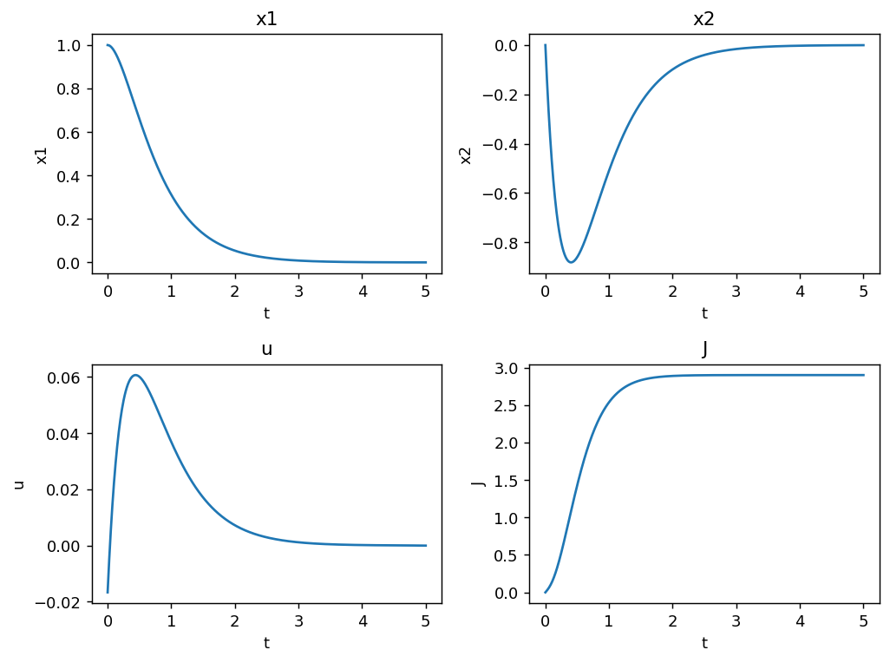

Cost for changed controller parameters
Scaling the optimal gain up or down increases the cost, confirming the dynamic-programming solution is optimal.
